PROGRAM 4 – FINISHING THE BILLING SYSTEM

OBJECTIVE
It’s time to finish our Billing system. Your lab team will work together to complete each deliverable for this final assignment. Your team will produce the following:
- Complete the Billing Entry program (program 4) by writing each employee record to a file
- A separate program which produces an ad-hoc management report (program 5)
- A separate program which will function as a menu allowing the user to run the management report (program 5) and the Billing entry program (program 4)
- Prepare a presentation where your team will demonstrate the functionality, provide a code walkthrough, and discuss design choices in your code and lessons learned

Note: All members of the team are expected to code part of the solution.

PART 1 – WRAPPING UP THE BILLING ENTRY PROGRAM (PROGRAM 4)
Many times, an application will save data to a file for later retrieval and use by other programs. The Billing Entry program thus far allows employee information to be entered but does not save them as logical records to a file.
You will extend your Billing Entry program to write employee information to a file for later retrieval.
INPUT:
There are no new input requirements

PROCESSING
The following processing modifications will be made:
- The billing information for each employee will be considered an individual (logical) record and written to a file named “Billing.txt” for later retrieval. The format is as follows:
  - Employee name, rate, week 1, week 2, week 3, week 4
Note: Below is an example of the expected format for your “Billing.txt” file when displayed using Notepad:
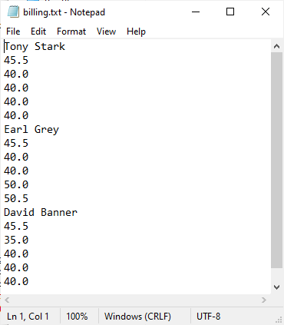
There should be exactly one logical record for each employee record added while the program executes. In the example above, three employee records have been written to the file implying the user chose to enter a second employee (Earl Grey) after they had entered the first (Tony Stark). The third employee (David Banner) was entered after Earl Grey.
- The contents of the “Billing.txt” file should be erased (reset) once each time the program starts (not after each employee record is written)
- You will create the following functions and add them to your “BillingModule.py” module.
  - resetBillingFile – Will allow the current file, if it exists to be deleted in anticipation for creating a new Billing.txt file
IPO Chart for the resetBillingFile Function
Input | Processing | Output
A string containing the name of the file to be reset | Remove all data from within the file | Nothing is returned from the function

- writeBillingRecord – Will open the “Billing.txt” file, write the logical record for the current employee (as defined above) and then close the file. The open, write and close will happen for each employee record written to the file.
IPO Chart for the writeBillingRecord Function
Input | Processing | Output
Six individual strings containing the fields which make up the employee logical record in the following order: Employee name, rate, week 1, week 2, week 3, week 4 | Using the arguments passed to the function, a new employee record is added to the Billing.txt file. | Nothing is returned from the function

The following validation rules will be added:
- Rate
  - Handle any/all runtime errors that occur
  - The minimum billing rate is $20.00/hour
  - “Invalid Hourly Rate, must be at least $20.00/hour.” Will be displayed should there be an error condition.
- Week 1 – 4
  - Handle any/all runtime errors that occur
  - The minimum hours of work allowed per week is 35
  - The maximum hours of work allowed per week is 80
  - “Invalid number of hours, must be between 35 and 80” will be displayed should there be an error condition

OUTPUT
There is no change to the Invoice report displayed on the console from previous programs. A new file named “Billing.txt” will be created containing each employee record entered when the program executes. The following data will be used to validate the program functions correctly:
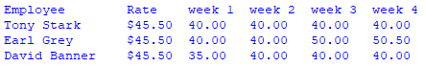
Each of the above test cases should produce the following output:

Test Case 1 – Tony Stark – Employee with no Overtime working standard hours
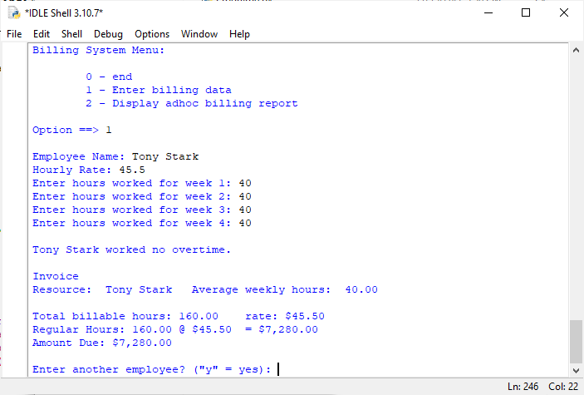

Test Case 2 – Earl Grey – Employee with Overtime
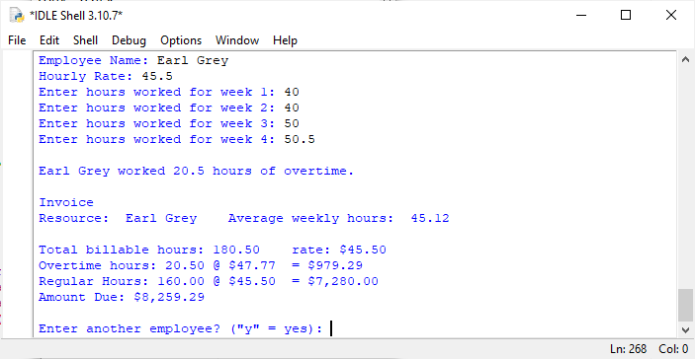
Test Case 3 – David Banner – Employee with no overtime working less than standard hours
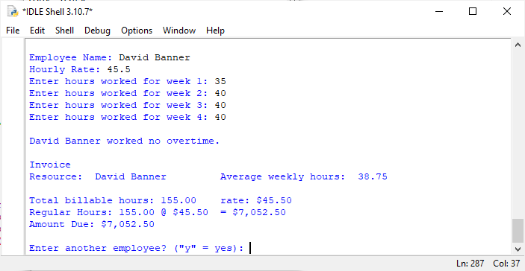

In addition to the above, all validation from previous assignments must be working correctly.

PART 2 - THE AD-HOC MANAGEMTN REPORT PROGRAM (PROGRAM 5)
It is very common in modern systems to have multiple steps to process data. And sometimes there are programs that just produce ad-hoc reports for managers and others involved in managing the business process. Now that the Billing entry program is functioning to the point where we are saving billing data, you will turn your attention to creating a simple ad hoc management report. These types of reports are called control reports since they are generally used by accountants and managers to get a quick snapshot of where things stand at a point in time.
We will write a program that reads the Billing.txt file created by the Billing Entry program and produce some control totals. You know what good modular form is and have capitalized on the use of functions and modules, a concept which should be extended to all future programs.
INPUT:
There is no console input, the program will read each logical record in the Billing.txt file and produce the intended control report.
PROCESSING
For each employee record the total of all for weeks of hours will be accumulated. The total billable amount will be calculated. Refer to previous programs and specifications for rules on calculating the amount to be invoiced. The numbers generated must match those generated by Billing entry program and be correct. Control totals will be accumulated for the following:
Total Billable Due – Is the total amount of billing receipts in dollars for the month. It is the total for all employees’ monthly total.
Total Billing Hours – Total hours billed for the month for all employees
Average Billable Hours – The average number of monthly billable hours across all employees.
Note: It is possible for a FileNotFoundError to be thrown if the Billing.txt file does not exist. This can happen if the report program is run before the Billing entry program; in that case Billing.txt will not exist. Be sure to handle the FileNotFoundError!
OUTPUT
Below is an example of the output to be printed on the console:
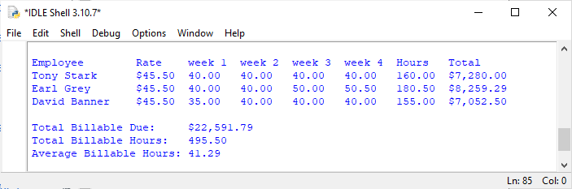
If the program is run when there is no Billing.txt file, the following output is to be displayed:
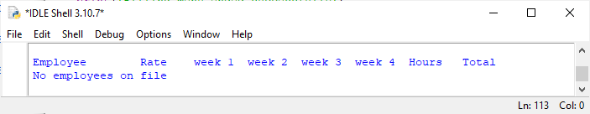
Note:
- Be careful when calculating totals to ensure you are rounding correctly! You should get the results above if you use these values as control data for your testing and they should agree with the totals produced by your billing entry program (Program4). Remember what we’ve discussed in class. If you have redundant code between two programs, that may be the target for a function to be shared between them.
- We have discussed the use of “helper functions”, your team should carefully consider which helper functions should be created to streamline your two programs.
- Since the Total due (“Total” column) is calculated by both programs, your team should consider a function which will calculate the total to be shared by both programs.
OUTPUT FORMATTING RULES
- All currency fields are to have the following:
o Dollar sign
o Two decimal places
o Appropriate comma separation
- All non-currency numeric fields are to have o Two decimal places
- Two or more text fields on the same line are to have a tab stop between them

PART 3 - THE MENU PROGRAM
At this point you have two working programs in your Billing system. The problem is the user must remember the names of every program they wish to run. And if there are many programs in a system this makes for a situation where the user is burdened with having to remember technical details in executing each program. So, you need to make your application easier to use. To do this you are going to build a simple menu program that could be easily extended if you found you had to add more options to the menu.
INPUT:
The menu program will accept an integer value corresponding to the option selected.
PROCESSING
Once the user selects an option the menu will determine the correct program and execute it. When the target program has completed executing, control is to be passed back to the menu program which will display the menu again and await the user’s next choice. If the user enters a value of zero, the menu will end. If the user enters a value which is not a valid selection, an appropriate message is to be displayed (see below), the menu displayed again, and the program will await the user’s input. Any errors generated must be properly handled using the Python exception handling mechanism.
OUTPUT
When the program starts execution, the following menu will be displayed:
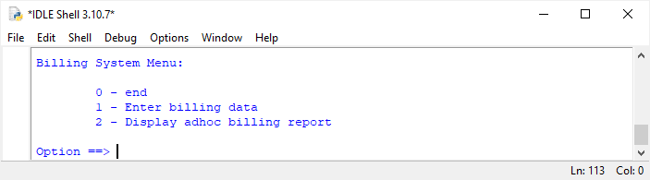

The program will accept input after the “Option==>” prompt. If the user selects an option that is not available on the menu, the following message will be displayed, and the menu will be displayed again, and user input will be solicited:
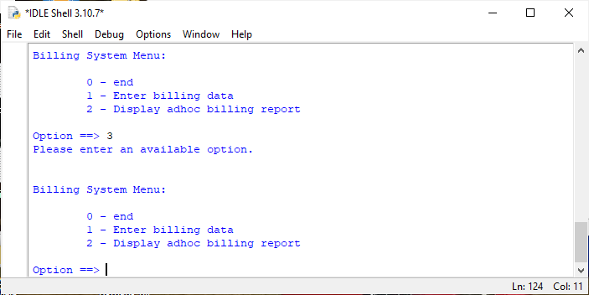

PART 4 – TEAM PRESENTATION
Your team will have 15 minutes to present, all team members are expected to present:
- Your working application
- A code walkthrough
- Discuss design choices
- Lessons learned
- Leave time for questions
You will demonstrate the functionality of your Billing system using the test script in the section “Final Program Testing Script” below. All input data is supplied and must be used verbatim. Each test case must be run in the order documented.

HOW YOU WILL BE GRADED
- You will be graded on the completeness of your team’s billing system
- How professional your presentation is

WHAT ARE THE DELIVERABLES
All of your source files (Module, Program4, Program5, and Menu) will be uploaded to the Canvas assignment along with the PowerPoint presentation.

Final Program Testing Script

OBJECTIVE
Your team will use this test script, in order, when testing and presenting your finished Billing program solution
Case 1 – Invalid choice from the menu
- Start your application menu
- Select an option that does not appear on the menu
  - The result should be an error message and the menu should redisplay
- Enter a non-numeric value as the option
  - The result should be an error message and the menu should redisplay
- Select option “0” to end the menu

Case 2 – User attempts to run the ad-hoc report without a billing.txt file
- Using a tool like “file manager”, navigate to the folder containing your project and delete the billing.txt file
- Start your application menu and select option “2” to run the ad-hoc billing report
  - The result should be an error message under the report heading and the menu should redisplay

Case 3 – Verify “Employee Name” validation
- From your application’s menu, select option “1” to run the Billing Entry program
- Verify the name field has a validation edit by pressing the enter key without entering any characters
  - The result should be an error message and the program should prompt the user again for a valid name
- Enter “Tony Stark” as the name
  - The result should be that the program accepts the name as valid and continues

Case 4 – Verify the “Hourly Rate” validation
- Press the enter key without entering any “Hourly Rate”
  - The result should be an error message and the program should prompt the user for a valid rate
- Enter non-numeric data in the “Hourly Rate” field and press the enter key
  - The result should be an error message and the program should prompt the user for a valid rate
- Enter a numeric value less than $20.00 in the “Hourly Rate” field and press the enter key
  - The result should be an error message and the program should prompt the user for a valid rate
- Enter 45.5 as the rate
  - The result should be that the program accepts the value as valid and continues

Case 5 – Verify the Weekly Hours validation
Note: validation will be tested for week 1’s hours, there’s no need to validate the remaining three weeks. Code inspection will verify if the code works for all weeks.

- Press the enter key without entering any weekly hours
  - The result should be an error message and the program should prompt the user for a valid number of hours worked
- Enter non-numeric data after the week 1 prompt and press the enter key
  - The result should be an error message and the program should prompt the user for a valid number of hours worked
- Enter a numeric value less than 35 after the week 1 prompt and press the enter key
- The result should be an error message and the program should prompt the user for a valid number of hours worked
- Enter a numeric value greater than 80 after the week 1 prompt and press the enter key
- The result should be an error message and the program should prompt the user for a valid number of hours worked
- Enter 40 as the hours worked for week 1
  - The result should be that the program accepts the value as valid and continues

Case 6 – Produce a valid invoice for a standard month (all weeks are 40 hours worked)
- Enter 40 for the hours worked for the remaining three weeks
  - The result should be that the program produces the correct invoice for Tony Stark, refer to the assignment for the screenshot with the correct values and formatting

Case 7 – Verify the validation for the prompt to enter another employee
- When prompted to enter another employee enter a “y”
  - The result should be that the program allows the user to enter another employee by prompting for the employee’s name

Case 8 – Verify the overtime invoice is produced correctly
- Enter the following data for each field as shown:
  - Employee Name – Earl Grey
  - Hourly Rate – 45.5
  - Hours for week 1 – 40
  - Hours for week 2 – 40
  - Hours for week 3 – 50
  - Hours for week 4 – 50.5
- The result should be that the program produces the correct invoice for Earl Grey, refer to the assignment for the screen shot with the correct values and formatting

Case 9 – Verify the invoice is correct for an employee with no over time working less than standard hours
- Execute “Case 7”
- Enter the following data for each field as shown
  - Employee Name – David Banner
  - Hourly Rate – 45.5
  - Hours for week 1 – 35
  - Hours for week 2 – 40
  - Hours for week 3 – 40
  - Hours for week 4 – 40
- The result should be that the program produces the correct invoice for David Banner, refer to the assignment for the screen shot with correct values and formatting

Case 10 – Validate the billing.txt file is correct
- Enter “n” when prompted to enter another employee
  - The result should be that the billing entry program ends normally and the menu is redisplayed
- Using a tool like “file manager”, navigate to the folder containing your project and open the billing.txt file
  - The result should be the employee records for all three of the above cases have been correctly written to the billing.txt file. Refer to the assignment for the screen shot of the billing.txt file with all three employee records

Case 11 – Verify that the ad-hoc report program produces the correct report
- From your application’s menu, select option “2” to run the ad-hoc billing report program
  - The result should be that the ad-hoc billing report should be displayed. Refer to the assignment for the screen shot with the correct values and formatting
  - Once complete, it will end normally and the menu will be redisplayed
  - Select option “0” to end the menu program normally

